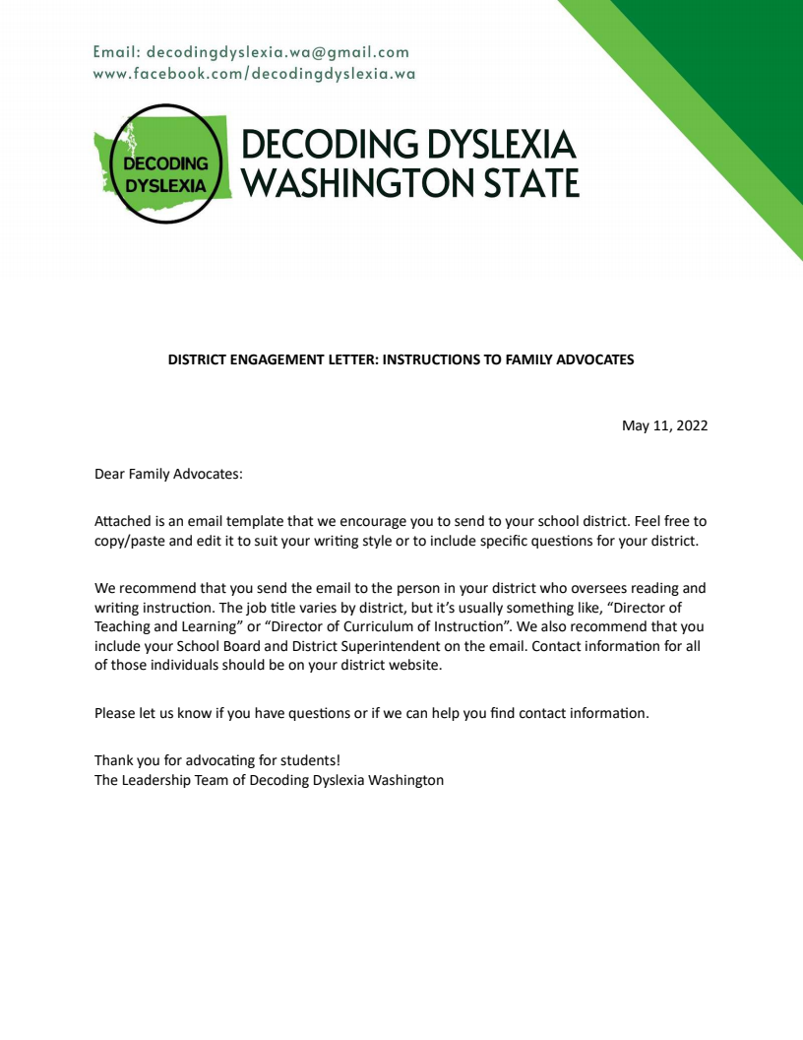
P.S. If you’re looking for more information about the new dyslexia screening law, visit our website: https://www.decodingdyslexiawa.org/files . If you’re looking to build your knowledge as a literacy advocate, join us for this upcoming webinar co-hosted with the Seattle Special Education PTSA: https://www.facebook.com/events/502288744922540/ or https://www.eventbrite.com/e/literacy-advocacy-101-tickets-336953746727

DISTRICT ENGAGEMENT LETTER: EMAIL TEMPLATE

Dear {DISTRICT ADMINISTRATOR}:

Great strides are being made with the implementation of the new dyslexia screening law (E2SSB 6162) throughout the state. Perhaps you’ve seen the recent Seattle Times articles about what has been happening in Wenatchee and Mercer Island? (See: Fed Up with Lackluster Reading Scores, Wenatchee Schools Turned to Science and How Do You Move the Needle on Literacy? This Eastside City is Retraining Teachers.)
Since adopting a structured literacy approach, Wenatchee school district staff have seen significant improvement even when students were mostly doing online learning and noted that “fewer students are at rock-bottom.” At the end of her first full school year teaching this method, one teacher said that, “80% of her first grade class had aced a phonology test — nothing she’d seen before in previous years.” Mercer Island school district staff have also begun to make the switch to structured literacy, beginning with extensive teacher training and now working with coaches and facilitators to implement this instructional approach with students. They, too, are seeing signs of early signs of success as fewer students are being flagged for indicators of dyslexia.

I am interested to know how our district is working to better serve our students. There have been a number of questions raised by families regarding school screenings required by the new law. I would like to know:
- What screener has our district chosen to use for screening foundational literacy skills?
- How do you notify families that a student has an identified weakness in foundational literacy skills?
- What specific interventions are planned for these students, how does that fit within a Response to Intervention (RTI) or Multi-Tiered Systems of Support (MTSS) framework, and how is this communicated to families?
- What multisensory structured literacy training have teachers received to support identified students?
- What additional training is planned for teachers that is aligned with the Science of Reading?
- Is there a plan to critically evaluate our district’s core literacy curriculum?

I appreciate your time and would welcome the opportunity to discuss family engagement and communication with district staff.

Sincerely,
{YOUR NAME}

cc: School Board Directors, District Superintendent

P.S. For further reading on reading and literacy in Washington State, please refer to the following articles from the Seattle Times: What Exactly Does the Science Say About Reading Instruction, What Happened When Schools Used Science to Revamp How Reading is Taught, and Students in Washington Struggle in Washington: Will a Fresh Approach to Reading Be Enough.

